**The Module Object**:

Documentation: <https://nodejs.org/dist/latest-v16.x/docs/api/modules.html#modules_the_module_object>

date.js

*(this is an incomplete module with nothing exported)*

1. console.log(module);
3. function getDate() {
4. // Sample: Wed Aug 04 2021 13:45:50 GMT+0800 (China Standard Time)
5. const date = new Date();
7. // object "options" is a time format for parameter options (line 19) using styles.
8. const options = {
9. month: "long",
10. day: "2-digit",
11. year: "numeric",
12. weekday: "long",
13. };
14. return date.toLocaleDateString("en-US", options);
15. }

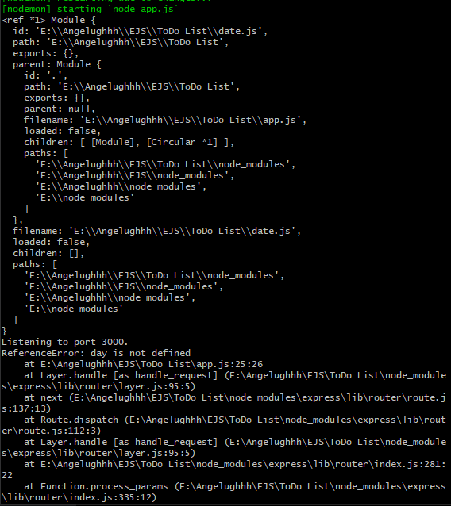

NOTE:

I don’t understand why there are double backslashes displayed on the path strings.

***day.js Module***

Module {

*this is where your module is located and is currently in a local directory*

**id**: 'E:\\Angelughhh\\EJS\\ToDo List\\date.js',

path: 'E:\\Angelughhh\\EJS\\ToDo List',

*this property* ***exports*** *is a js object (as denoted by the curly braces)*

*at the moment, this indicates that your day.js module is not exporting anything*

**exports**: {},

*the actual parent module’s details that launched/required this day.js module*

parent:

Module {

id: '.',

path: 'E:\\Angelughhh\\EJS\\ToDo List',

exports: {},

parent: null,

*parent module (of day.js) is app.js*

filename: 'E:\\Angelughhh\\EJS\\ToDo List\\app.js',

loaded: false,

*example of the children property are the required express and body-parser*

children: [ [Module], [Circular *1] ],

paths: [

'E:\\Angelughhh\\EJS\\ToDo List\\node_modules',

'E:\\Angelughhh\\EJS\\node_modules',

'E:\\Angelughhh\\node_modules',

'E:\\node_modules'

]

},

filename: 'E:\\Angelughhh\\EJS\\ToDo List\\date.js',

loaded: false,

children: [],

paths: [

'E:\\Angelughhh\\EJS\\ToDo List\\node_modules',

'E:\\Angelughhh\\EJS\\node_modules',

'E:\\Angelughhh\\node_modules',

'E:\\node_modules'

]

}

Listening to port 3000.

**Module.Exports**

File: app.js

1. const date = require(__dirname + "/date.js");
2. console.log("Module 'date.js': ", date);

**Line 01:**

**date.js** is a local node module (and not yet located in the server) so it needs an additional *__dirname* to locate it.

Once the code runs, it will try to execute all the code inside date.js first and bind it to const "**date**" before proceeding to run the next line of code (in this case, Line 02) in app.js.

File: day.js

1. module.exports = getDate;
2. console.log(module);
4. function getDate() {
5. // Sample: Wed Aug 04 2021 13:45:50 GMT+0800 (China Standard Time)
6. const date = new Date();
8. // object "options" is a time format for parameter options (line 19) using styles.
9. const options = {
10. month: "long",
11. day: "2-digit",
12. year: "numeric",
13. weekday: "long",
14. };
15. return date.toLocaleDateString("en-US", options);
16. }

**Line 01:**

With .exports this current date.js module will export its equivalent value or function.

In JavaScript Objects, when adding parenthesis after a function name, you are executing/invoking the function.

**getDate** function has no parenthesis so we can allow app.js (parent module) to determine when to invoke the function.

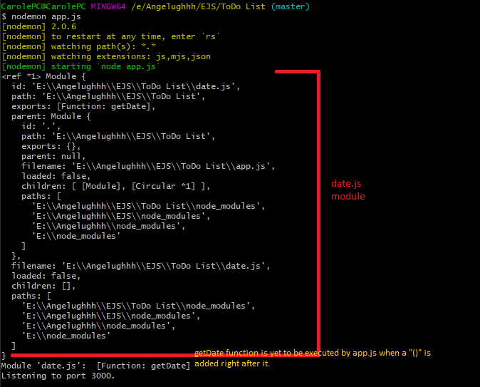

**module.exports** is a JavaScript object and objects have properties and methods associated with it.

Note: If you would only like to configure the content options, but still use the current locale, passing null for the first parameter will cause an error. Use undefined instead.

Pushing to Git returning Error Code 403 fatal: HTTP request failed

<https://stackoverflow.com/questions/7438313/pushing-to-git-returning-error-code-403-fatal-http-request-failed>

<https://docs.github.com/en/github/authenticating-to-github/connecting-to-github-with-ssh/about-ssh>

